

**Object Oriented Programming – Final Project**

**Group 08**

**University of Sri Jayewardhanepura**

**Faculty of Humanities and Social Sciences**

**Department of information and Communication Technology**

* Project title : Clinic Management System
* Group Number: 08
* Group Members

|  |  |  |
| --- | --- | --- |
| Name | AR Number | Index number |
| A.M.M.P. Abeykoon | AR/92861 | AF/17/13308 |
| A.A.M.M.W.C.D. Mediwaka | AR/93301 | AF/17/13748 |
| S.D. Lokuge | AR/93304 | AF/17/13751 |
| W.M.T. Dilhan | AR/93335 | AF/17/13780 |

* GitHub link: [Mah-eshh/Clinic-Managment-System (github.com)](https://github.com/Mah-eshh/Clinic-Managment-System)
* Department of Information and Communication Technology

Object Oriented Programming (2101.03)

Second Year-First Semester-Final Project

**Class Diagram**

**(Clinic Management System)**

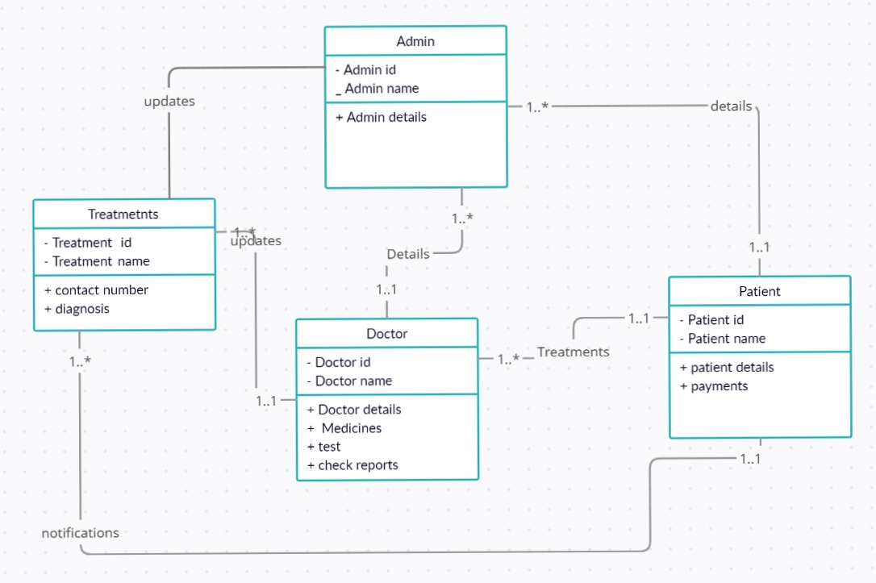

**Use Case Diagram**

**(Clinic Management System)**

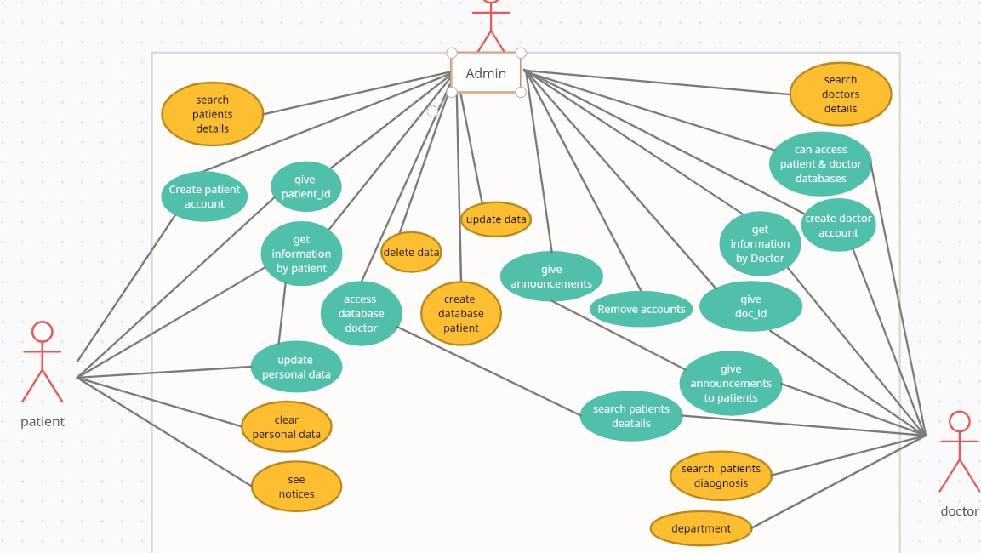

Frontend: Java Projects

Backend: MySQL Projects

This project **Clinic Management System** is **Java JSP and MySQL project** which runs on the Xampp server, you can also run this project in Eclipse and Netbeans. We have develop this **Java JSP and MySQL project on Clinic Management System** for automating the process of Clinic Management System.

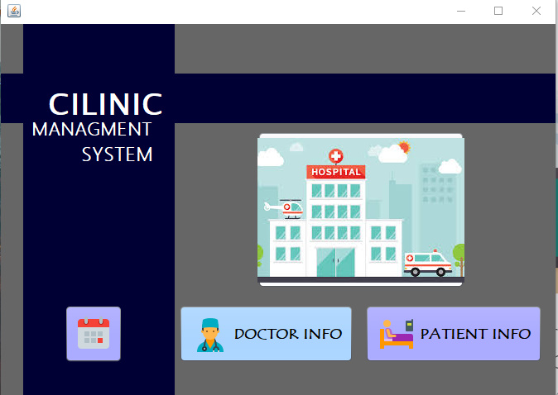

**The main features of this project is to manage clinic, patients, doctors, medicine, test and appointments**.

This is a **major project in java** which suitable for students who learning Java language. The main modules at the project is clinic module, patients module, doctors module, medicines module and test module which performs all the operation in their respective domains. **Java project on Clinic Management System is secured web application which run inside the JVM.**

You can **download java project on Clinic Management System** from our University’s Digital learning space. Also we provide **Clinic Management System** **project report** along with this project. If you are booking for spring, EJB, hibernate Clinic Management System project then we can develop it also according to your requirements.

This is a **web application projects in java free download,** which you can run easily on any of web browser.

Within this project, we learnt how to develop a simple java project with source code for beginners.

**Report of Clinic Management System**

* **Login:** Admin user and Doctors can access for patients details list. Doctors can access only for Doctors’ details.

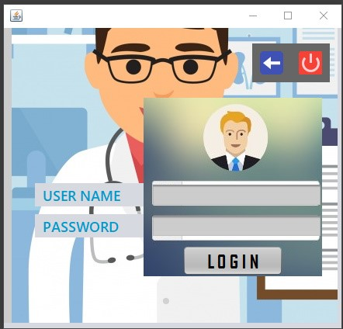

* **Login:** Doctors and admin users can access to patients login section. Also it is managing by them so doctors and admin users are updating, deleting the details of patients who are getting treatments

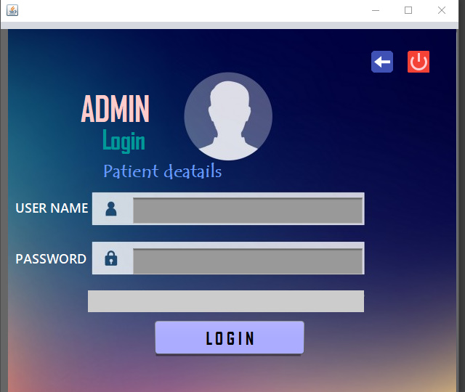

* **Clinic report:** We can generate unlimited numbers of reports by using this

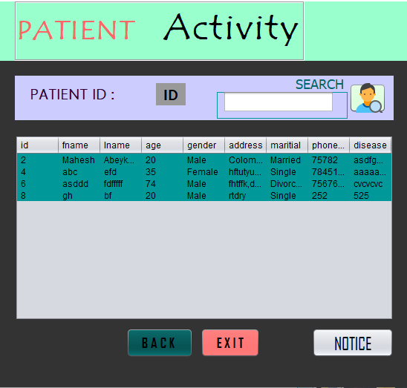

* **Patient report**: Generate reports related to patients

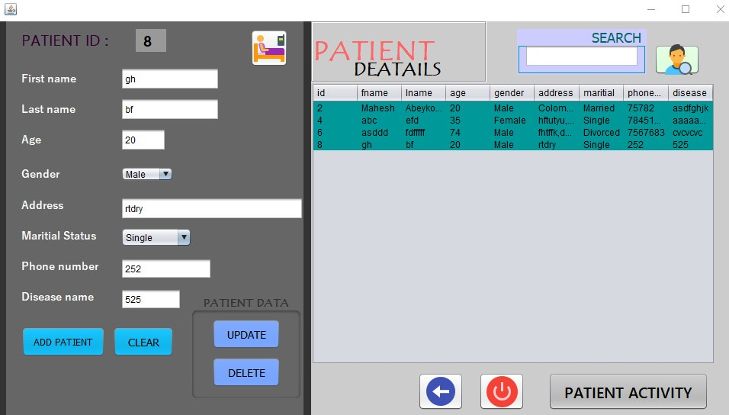

* **Doctors report**: All doctors’ reports and details will be available in this section

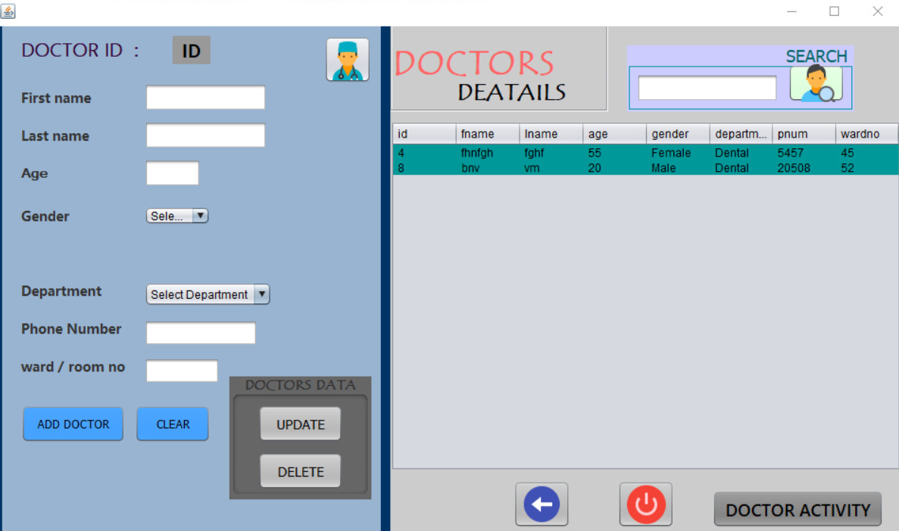

* **Clinical notices:** All the patients can get newly updated notices within a text message instantly.

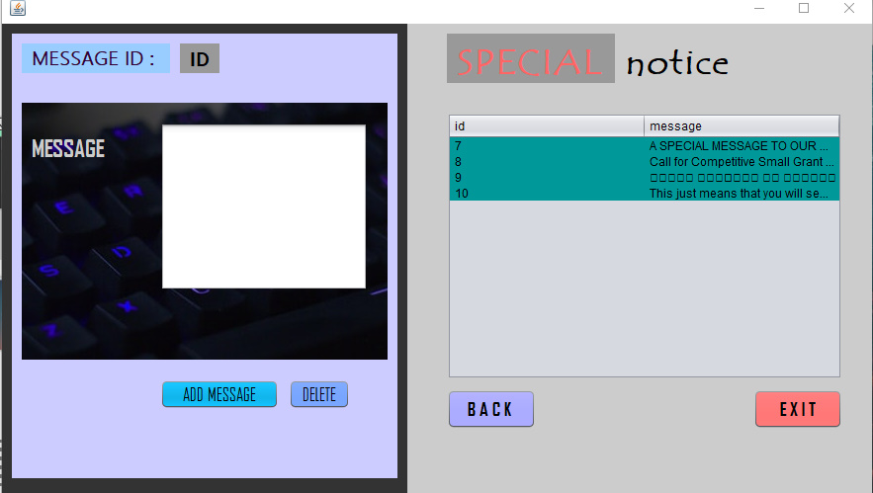

* You can generate filtered reports of medicine and clinical tests.
* Patients, appointments, doctors has facility for dynamic search. So you can filter the records run time
* PDF reporting has been integrated for exporting of the report for clinic, patient, doctor modules.
* Admin can print a label of patients details, it can use in all times to get details.
* You can create the CSV reports for clinic, medicine, patients.

**Modules of Clinic Management System**

* **Clinic module:** We can manage all the operations related to clinic from this module.
* **Patient module:** This module is normally developed for managing the patient operations.
* **Doctor module:** All the operations related to doctors will be managed by doctors and admin users.
* **Medical module:** This module manages medicines functionalities.
* **Test module:** Testmodules performs all new creates, read, update, print and delete operations of test.
* **Appointment module:** It manages all the functionalities of appointments.

**Clinic Management System Installation steps**

* Download Clinic Management System zip file and extract it
* Copy Clinic Management System inside the webapps folder
* Open phpmyadmin and create Clinic Management System database
* Import database Clinic Management System
* Open your browser run the project [Mah-eshh/Clinic-Managment-System (github.com)](https://github.com/Mah-eshh/Clinic-Managment-System)

**Software needed to run Clinic Management System**

* JDK 8.0.2 to run this project you have JDK 8.0.2 version
* Xampp 3.2.4: This project runs over the Xampp server
* NetBeans IDE 8.0.2

**THANKYOU!**